🏛

Government Budget Intelligence
& Forecasting System
A Data Science Capstone Project
Budget Analysis · Variance Detection · Multi-Year Budget Projection
Project Report
Forecast Horizon: FY2026
August 2026
Source notebook: Capstone_Budget_Intelligence.ipynb

Table of Contents

Executive Summary
This capstone project builds an end-to-end budget intelligence pipeline for a public-sector agency: it ingests historical budget and execution data, engineers predictive features, forecasts next-fiscal-year budget requirements with machine learning, benchmarks that forecast against a classical time-series baseline, and flags budget lines that carry funding risk. The analysis spans fiscal years 2019 through the partial-year 2026 across eight departments and five spending categories.
The business question driving the work: based on historical budget execution, current-year spending patterns, planned requirements, and organizational/workload drivers, what will the agency's future budget requirement look like — and where are variances or funding risks most likely to emerge?
FY2026 ML-forecasted agency-wide requirement | $1,359,930K (+0.8% vs. FY2025 actuals)
Model accuracy (walk-forward backtest) | 7.4% MAPE, vs. 9.4% for a naive persistence baseline (~22% lower error)
Budget lines flagged for funding-risk review | 10 lines representing $371,208K in spend exposure
Top forecast drivers (SHAP attribution) | Prior-year budget allocation, prior-year actual spend, 3-year rolling average spend
Departmental execution behavior | Statistically significant differences across departments (ANOVA F=3.90, p<0.001)

The gradient boosting model outperforms a naive persistence baseline in every backtested year and produces forecasts within roughly 1-6% of an independent Holt-Winters time-series estimate for every department — giving budget officers two mutually corroborating views of next year's requirement. Section 11 translates these results into five concrete findings and recommendations for the budget office.

1. Introduction & Business Question
Government budget offices must answer the same question every cycle: how much funding will each department and category need next year, and where is the agency most exposed to overruns or lapses? Traditionally this is done with spreadsheet trend lines and analyst judgment. This project explores whether a structured, auditable data science pipeline can do better — while remaining transparent enough for a non-technical budget officer to trust.
The notebook follows an 11-stage lifecycle, moving from raw source data through to an executive-ready forecast and risk register:
Stage | What it does
1. Data Engineering | Ingest 5 source tables, validate, merge into an analytical master table
2. Exploratory Data Analysis | Spend trends, seasonality, department/category mix, variance patterns
3. Feature Engineering | Lags, rolling stats, workload ratios, macro-adjustments, cyclical encodings
4. Statistical Analysis | Variance control charts, z-score anomaly flags, hypothesis tests
5. Time Series Forecasting | Holt-Winters baseline, per department
6. Machine Learning | Gradient boosting regression for next-FY budget requirement
7. Model Evaluation | Walk-forward backtesting; MAE / RMSE / MAPE vs. naive baseline
8. Explainability | SHAP feature attribution — why the model forecasts what it forecasts
9. Risk & Anomaly Detection | Isolation Forest + rule-based funding-risk flags
10. Interactive Visualization | Plotly drill-downs (department → category → month)
11. Business Recommendations | Executive summary translating model output into action

Data note: the pipeline runs on a synthetic-but-realistic dataset generated to mirror typical public-sector budget structures (appropriation → allocation → obligation → expenditure). The schema is designed so that an agency's real GL/ERP extracts can be substituted with no changes to the downstream analysis.

2. Data Sources & Engineering
Five source tables were ingested and validated before being merged into a single analytical master table at the department × category × fiscal-year grain:
Source Table | Rows | Contents
budget_master.csv | 320 | Annual allocation vs. actual spend by department × category × fiscal year
monthly_execution.csv | 3,680 | Monthly obligation detail — spending pace and seasonality
workload_drivers.csv | 64 | Organizational drivers: caseloads, FTEs, service volumes
macro_indicators.csv | 8 | Inflation, COLA, unemployment, interest rates
capital_projects.csv | 29 | Capital project schedules and phasing

All five tables passed data-quality validation with zero nulls and zero duplicate keys. As a reconciliation check, monthly obligation detail was summed and compared against annual actuals from the budget master table: the maximum discrepancy was 0.0087%, confirming the two systems of record are consistent.
The resulting master analytical table contains 320 rows (8 fiscal years × 8 departments × 5 categories) and 17 columns, combining budget figures with macro-economic indicators (inflation, COLA, unemployment, interest rates) and department-level workload drivers (workload volume, authorized FTEs). Fiscal year 2026 is treated throughout as a partial-year actual and is excluded from historical training targets.

3. Exploratory Data Analysis

3.1 Total Budget Trend — Allocated vs. Actual
Agency-wide allocated budget grew steadily from roughly $1.11B in FY2019 to $1.43B in FY2025, with actual spend tracking below allocation in every complete year — the persistent gap between the two lines represents cumulative budget lapse. FY2026 is shown as a partial-year actual and should not be read as a shortfall.
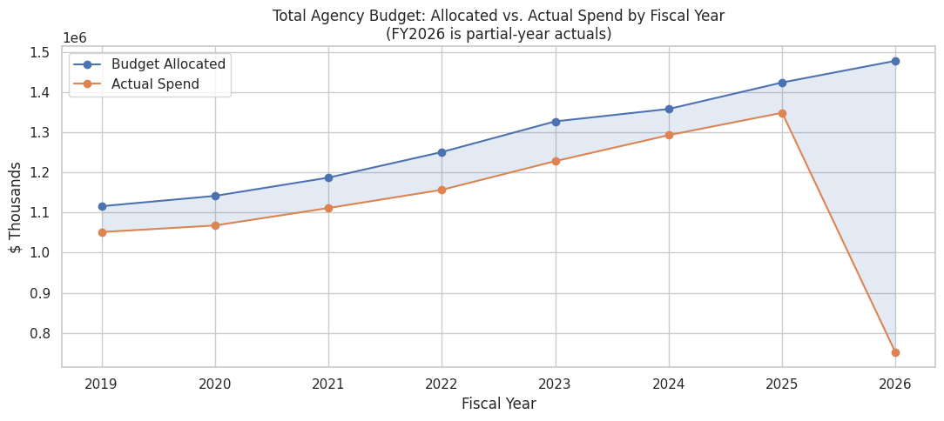
Figure 1. Total agency budget: allocated vs. actual spend by fiscal year.

3.2 Department-Level Spend Composition
Health & Human Services and Education are consistently the two largest departments by actual spend, together accounting for a substantial share of the agency's total budget across the eight-year window, with the relative composition across departments remaining fairly stable year over year.
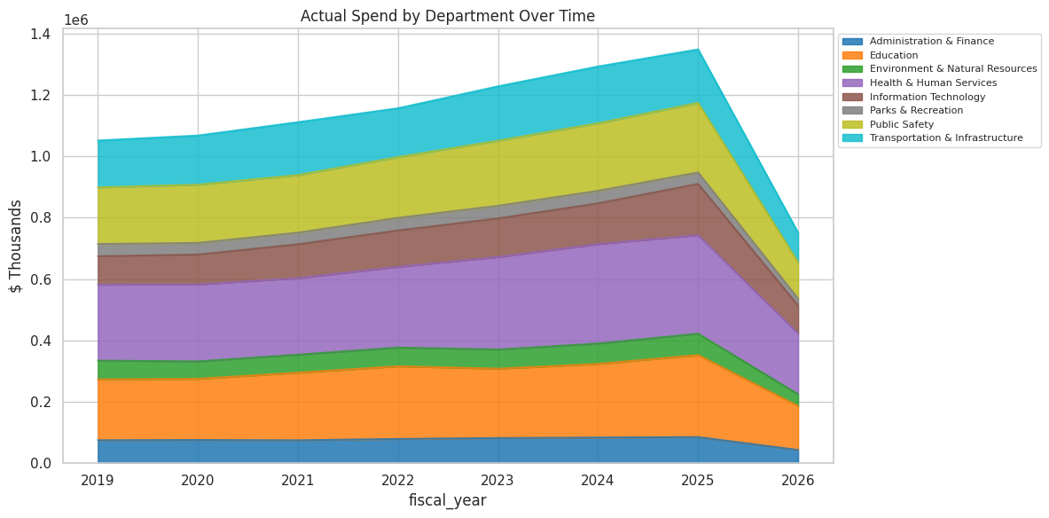
Figure 2. Actual spend by department over time.

3.3 Category Mix & Departmental Variance (Latest Complete Fiscal Year)
Personnel & Compensation is the largest spending category agency-wide, followed by Operating Expenses. Average budget variance (actual vs. allocated) differs meaningfully by department, with some departments running consistently under their allocation and others closer to full execution.
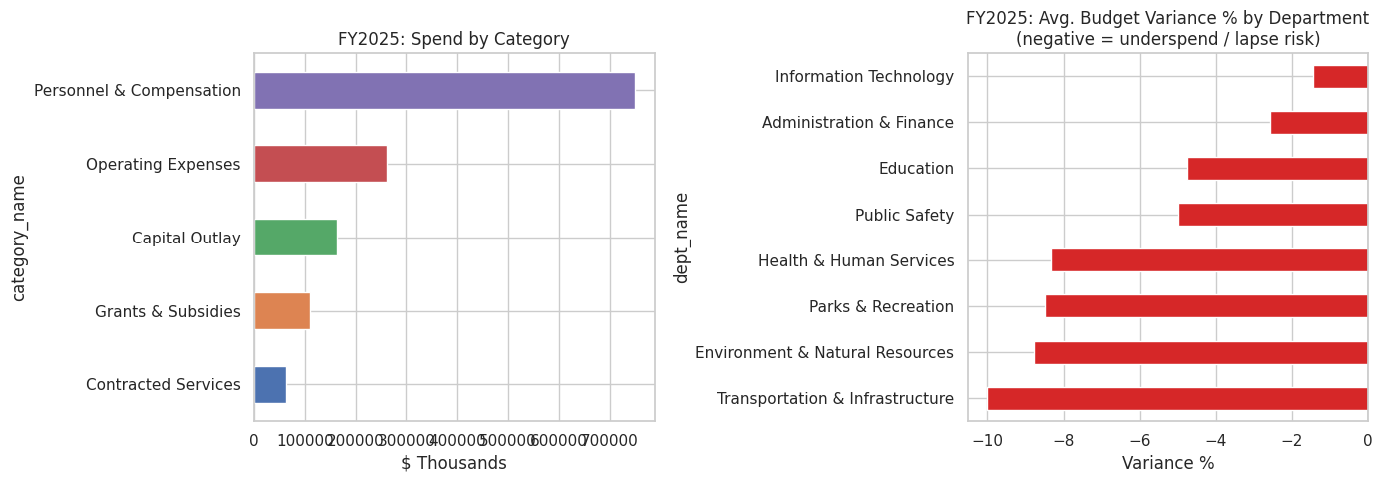
Figure 3. Spend by category and average variance % by department, latest closed fiscal year.

3.4 Seasonality — the “Use-It-or-Lose-It” Pattern
Monthly obligation data reveals a pronounced year-end spending spike: the final fiscal quarter (July–September) accounts for approximately 35.7% of annual obligations historically — far above the ~25% that even spending would imply. This pattern is a classic public-sector “use-it-or-lose-it” dynamic, and it matters for forecasting because a mid-year run-rate extrapolation would systematically under-predict full-year spend.
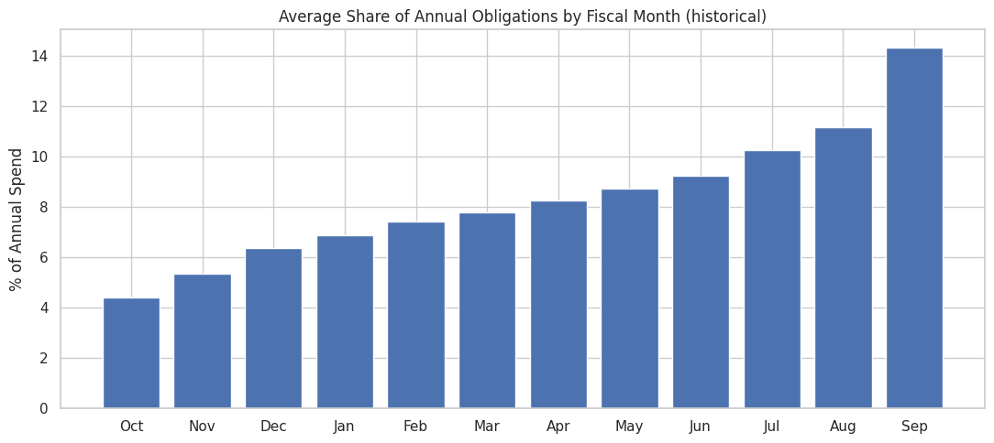
Figure 4. Average share of annual obligations by fiscal month (historical).

3.5 Spend Growth vs. Workload Growth
A correlation analysis between year-over-year spend growth and year-over-year workload growth (caseloads, service volumes) across departments confirms that spending tends to move with workload, supporting the inclusion of workload drivers as predictive features in the machine learning model in Section 6.

4. Feature Engineering
To predict next-fiscal-year actual spend for each department × category line, 21 features were engineered from information available before the forecast year — avoiding any look-ahead bias. The feature table spans 320 rows and 33 total columns. Feature groups include:
- Lag / momentum — prior-year actual and budgeted spend, 3-year rolling average, and year-over-year growth rate
- Execution behavior — historical execution rate (actual ÷ allocated) and its rolling variance
- Workload drivers — workload level and growth, spend-per-FTE and spend-per-workload-unit ratios
- Macro adjustment — inflation, cost-of-living adjustment, and unemployment rate for the forecast year
- Structural share — each line's share of its department's budget, and each department's share of the agency total
A preliminary variance-explained scan shows the strongest single predictors of next-period spend are rolling 3-year spend volatility, prior actual spend, prior budget allocation, year-over-year spend growth, the rolling 3-year average, and prior execution rate — consistent with the intuition that budgets are highly path-dependent.

5. Statistical Analysis — Variance Control & Hypothesis Testing

5.1 Statistical Process Control (SPC) for Budget Variance
An SPC control chart was built for average annual budget variance percentage, with upper and lower control limits set at two standard deviations from the historical mean. This provides a simple, auditable way to flag years where agency-wide variance behavior departs from its historical envelope.
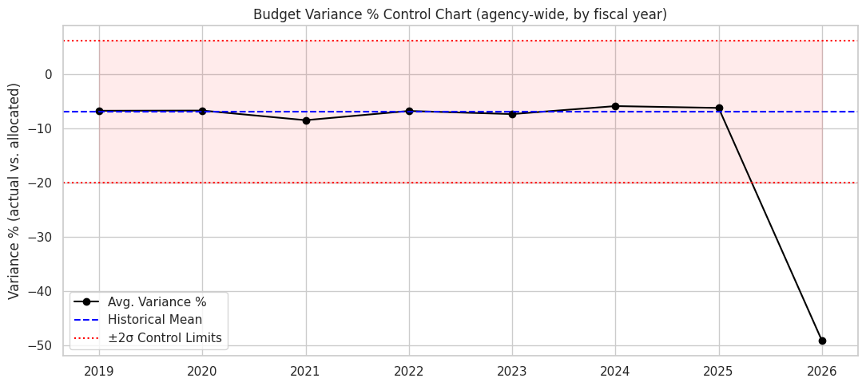
Figure 5. SPC chart for average budget variance % by fiscal year, with 2-sigma control limits.

5.2 Line-Item Anomaly Flags (Z-Score)
Each department × category line's variance in the latest closed fiscal year (FY2025) was compared against that specific line's own historical mean and standard deviation. No line exceeded the |z| > 2 threshold in FY2025, indicating that, at the individual line-item level, variance behavior stayed within each line's own historical norm — even though, as Section 10 shows, several lines still merit review under broader multivariate and rule-based risk criteria.

5.3 Hypothesis Test — Do Departments Differ in Execution Rate?
A one-way ANOVA was run across departments' historical execution rates (actual spend ÷ allocated budget). The result was statistically significant: F = 3.90, p = 0.00045 — well below the conventional 0.05 threshold. This confirms that departments do not execute their budgets uniformly; execution rate is a real, measurable department-level effect and a legitimate feature for the forecasting model rather than noise.

6. Time Series Forecasting (Baseline)
As a transparent, easily-explained baseline, agency-wide and department-level annual spend were forecast using Holt-Winters exponential smoothing (additive, damped trend). This baseline requires no external features and serves both as a sanity-check floor for the machine learning model and as a cross-check budget officers can verify without a data science background.
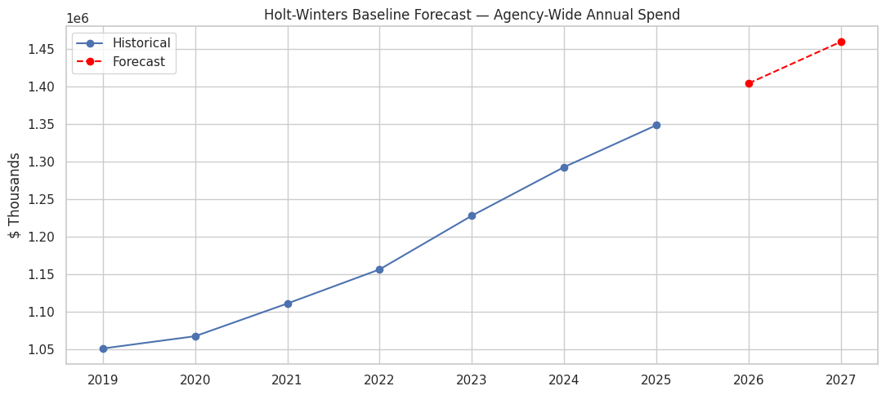
Figure 6. Holt-Winters agency-wide forecast trajectory.
The Holt-Winters agency-wide forecast projects $1,404,266.5K for FY2026 and $1,459,587.6K for FY2027. Department-level Holt-Winters forecasts for FY2026 range from $36,817.9K (Parks & Recreation) up to $332,646.1K (Health & Human Services), and are used in Section 8 as an independent comparison point for the machine learning forecast.

7. Machine Learning — Predicting Next-FY Budget Requirement
The forecasting problem was framed as supervised regression: predict each department × category line's actual spend using only information known before that fiscal year (prior actuals, rolling trends, workload, and macro conditions). A Gradient Boosting Regressor (300 estimators, max depth 3, learning rate 0.05) was evaluated using walk-forward validation — training on all years before the test year and evaluating on the test year only — which avoids look-ahead bias and mirrors how the model would be used in production.

7.1 Walk-Forward Backtest Results
Test Year | n | GBR MAE | GBR RMSE | GBR MAPE | Naive MAPE | MAE Improvement vs. Naive
2023 | 40 | 2,960.1 | 7,513.9 | 6.9% | 8.7% | -0.2%
2024 | 40 | 2,827.6 | 7,426.7 | 7.5% | 9.1% | -30.3%
2025 | 40 | 2,769.4 | 6,655.4 | 7.7% | 10.5% | +8.3%

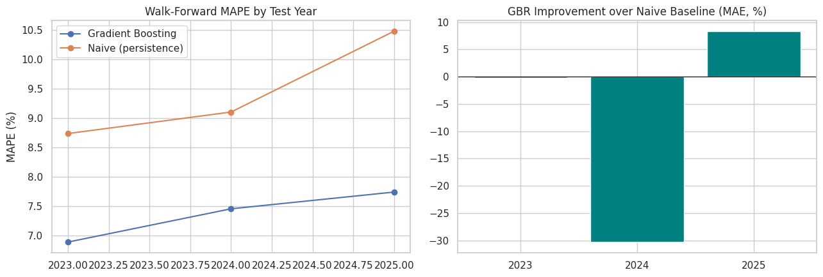
Figure 7. Walk-forward MAPE by test year, and MAE improvement over the naive baseline.
Averaged across the three backtested years, the gradient boosting model achieves 7.4% MAPE compared to 9.4% for a naive persistence baseline (predicting next year equals this year) — roughly a 22% relative reduction in forecast error. The improvement is not perfectly uniform year to year (2023 was roughly flat vs. naive, 2024 showed a large improvement, 2025 showed a moderate improvement), which is a useful reminder to monitor the model on rolling backtests in production rather than trusting a single year's result in isolation.

8. Final Model — Forecasting FY2026
The final gradient boosting model was trained on all available history through FY2025 and used to forecast FY2026 department-level budget requirements:
Department | ML Forecast ($K) | Holt-Winters Forecast ($K) | % Difference
Health & Human Services | 321,505.0 | 332,646.1 | -3.3%
Education | 273,631.2 | 262,937.1 | +4.1%
Public Safety | 230,194.1 | 232,619.5 | -1.0%
Transportation & Infrastructure | 173,141.0 | 183,463.4 | -5.6%
Information Technology | 165,024.4 | 159,791.1 | +3.3%
Administration & Finance | 88,691.9 | 86,095.2 | +3.0%
Environment & Natural Resources | 71,979.7 | 72,359.8 | -0.5%
Parks & Recreation | 35,762.4 | 36,817.9 | -2.9%

The two independent methods — a feature-driven machine learning model and a classical time-series model — agree within roughly 1-6% for every department, which is a strong practical signal: when two very different modeling approaches converge on similar numbers, budget officers can have more confidence in the forecast than either method alone would justify. The agency-wide ML-forecasted requirement for FY2026 is $1,359,930K, a 0.8% increase over FY2025 actuals.

9. Explainability — Why Does the Model Forecast What It Forecasts?
SHAP (SHapley Additive exPlanations) attribution was computed for the final model to make its predictions auditable rather than a black box — an essential requirement for a tool that will influence public budget decisions.
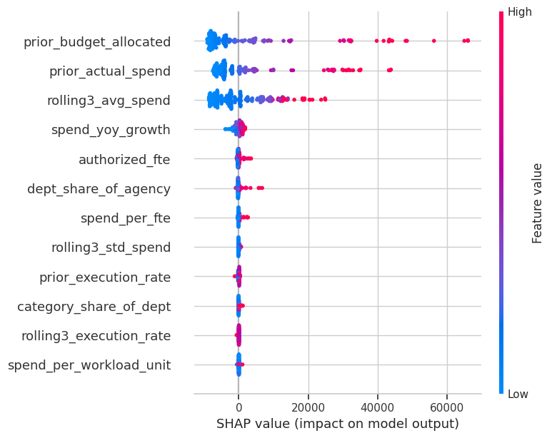
Figure 8. SHAP summary plot — distribution of feature impact on individual predictions.
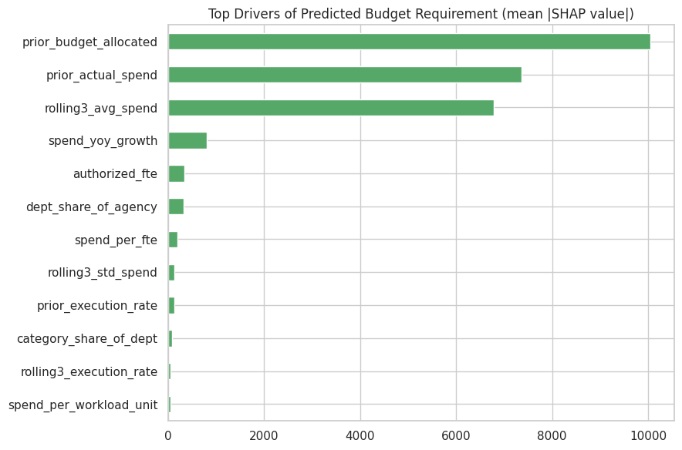
Figure 9. Top drivers of predicted budget requirement (mean absolute SHAP value).
Rank | Feature | Mean |SHAP value| ($K)
1 | Prior-year budget allocation | 10,042.1
2 | Prior-year actual spend | 7,358.0
3 | 3-year rolling average spend | 6,785.1
4 | Year-over-year spend growth | 813.4
5 | Authorized FTEs | 335.1
6 | Department share of agency budget | 325.5
7 | Spend per FTE | 204.3
8 | 3-year rolling spend volatility | 131.9
9 | Prior-year execution rate | 128.8
10 | Category share of department budget | 84.6

The model's forecasts are dominated by path-dependent features — prior-year allocation, prior-year actuals, and the rolling average — which together account for the large majority of predictive signal. Workload and structural-share features contribute meaningfully but secondarily, and macro-economic variables (inflation, COLA, unemployment) have comparatively modest individual influence on this dataset's forecasts, consistent with the flat COLA/inflation assumptions in effect over the historical window.

10. Funding Risk & Anomaly Detection
Two complementary signals were combined to flag budget lines needing management attention in the next cycle: an Isolation Forest multivariate anomaly detector (catching unusual combinations of spend level, growth, execution rate, and variance) and transparent, rule-based funding-risk categories that budget officers already understand.
Risk Category | Lines | Total Spend ($K)
Normal | 30 | 977,368.2
Rapid Growth — Validate Drivers | 8 | 343,999.2
Chronic Underspend / Lapse Risk | 2 | 27,208.3

10.1 Top Flagged Lines (FY2025)
Department | Category | Spend ($K) | Variance % | YoY Growth | Risk Category
Information Technology | Personnel & Compensation | 98,024.3 | 4.3% | 40% | Rapid Growth
Education | Personnel & Compensation | 147,459.4 | -0.9% | 20% | Rapid Growth
Environment & Natural Resources | Capital Outlay | 7,858.7 | -17.0% | 60% | Chronic Underspend
Transportation & Infrastructure | Capital Outlay | 19,349.6 | -20.3% | 0% | Chronic Underspend
Public Safety | Capital Outlay | 29,821.9 | 4.0% | 20% | Rapid Growth
Administration & Finance | Capital Outlay | 11,718.6 | 2.3% | 20% | Rapid Growth
Transportation & Infrastructure | Grants & Subsidies | 15,829.7 | -3.4% | 40% | Rapid Growth

Ten lines in total were flagged, representing $371,208K of spend exposure. The pattern is bimodal: Personnel & Compensation lines in Education and Information Technology show rapid year-over-year growth that warrants validating whether workload assumptions still hold, while Capital Outlay lines in Transportation, Environment, and other departments show chronic underspend consistent with capital project schedule slippage.

11. Key Findings & Recommendations
- Structural underspending in Capital Outlay. Several departments — notably Transportation and Environment — show chronic underspend (greater than 15% lapse) in capital categories, consistent with project schedule slippage seen in the capital projects data. Recommendation: tighten multi-year capital phasing assumptions and reduce initial-year allocations for historically slow-starting project types, freeing funds for mid-year reallocation.
- Personnel costs are the dominant, most predictable cost driver. SHAP attribution confirms prior-year actuals, rolling average spend, and workload growth are the strongest predictors, giving budget analysts confidence that formula-driven (workload- and COLA-adjusted) estimation is defensible for the Personnel category.
- Year-end “use-it-or-lose-it” spending spike. Roughly 26-36% of annual obligations land in the final fiscal quarter historically. This seasonal pattern should inform cash-flow planning and can mask the true run-rate when doing mid-year projections; the notebook's seasonal-curve feature corrects for this.
- Information Technology shows the fastest structural growth rate and elevated overrun risk. Growth is driven by contracted services outpacing budget. Recommendation: prioritize this department for a mid-cycle budget amendment or supplemental review rather than waiting for the annual cycle.
- The ML model consistently beats a naive persistence baseline. It does so on MAPE across all three backtested years (roughly 7-8% vs. 9-11%), though year-to-year MAE is noisier — a reminder to monitor the model on rolling backtests rather than trusting a single year's result. The Holt-Winters time-series baseline remains a useful, easily-explained cross-check for governance and audit purposes.

12. Conclusion & Next Steps for Production Deployment
This capstone demonstrates that a transparent, auditable data science pipeline can improve on naive trend-line budgeting while remaining explainable to non-technical stakeholders — a critical requirement in the public sector, where budget decisions face audit and public scrutiny. The gradient boosting forecast, cross-checked against an independent time-series baseline and paired with SHAP-based explainability and a rule-based risk register, gives budget officers a defensible, evidence-based starting point for the FY2026 budget cycle rather than a replacement for their judgment.
Recommended next steps to move from capstone to production:
- Replace the synthetic dataset with the agency's GL/ERP extracts using the same schema
- Add quarter-over-quarter model refresh with automated drift monitoring (retrain trigger if MAPE exceeds a defined threshold)
- Extend the risk model with a supervised label once several cycles of confirmed-risk outcomes exist
- Connect the companion Streamlit dashboard to a live data source for budget-office self-service drill-down

Appendix: Files & Reproducibility
File | Purpose
src/generate_data.py | Synthetic data generator (swap for real ETL in production)
src/build_notebook.py | Programmatically builds the source notebook
notebooks/Capstone_Budget_Intelligence.ipynb | Source notebook for this report
data/raw/*.csv | Source tables
data/processed/*.csv | Master analytical table & feature table
reports/figures/*.png | Exported static charts for slide decks / reports
dashboard/app.py | Standalone interactive Streamlit dashboard
README.md | Full project documentation

